Practice Set-1

Ques-1. Write a program for the addition of Two Numbers.

Code:

num1 = int(input("Enter 1st number"))  
num2 = int(input("Enter 2nd number"))  
sum = num1 + num2

print("Addition = ", sum)

Output:

Enter 1st number: 55

Enter 2nd number: 58

Addition = 113

Snapshot:

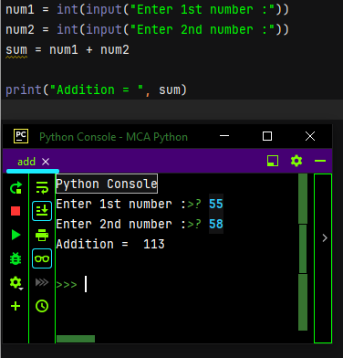

**Ques-2.** Write a program to read two numbers and print their quotient and remainder.

**Code:**

num1 = int(input("Enter 1st number"))  
num2 = int(input("Enter 2nd number"))  
ques = (num1 // num2)  
rem = (num1 % num2)  
print("quotient = ", ques)  
print("remainder = ", rem)

**Output:**

Enter 1st number>? 3215

Enter 2nd number>? 26

quotient = 123

remainder = 17

**Snapshot:**

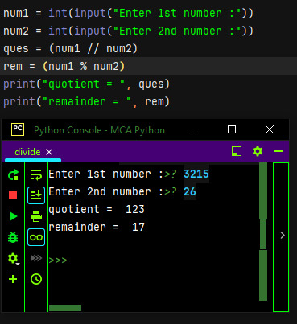

Ques-3. Write a program to find the Average of Three Numbers.

Code:

num1 = int(input("Enter 1st number"))  
num2 = int(input("Enter 2nd number"))  
num3 = int(input("Enter 3rd number"))  
avg = (num1 + num2 + num3)/3  
print(avg)

Output:

Enter 1st number>? 55

Enter 2nd number>? 69

Enter 3rd number>? 98

Average = 74.0

Snapshot:

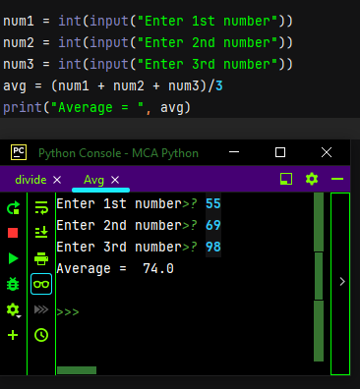

**Ques-4.** Write a program to Calculate Sum of 5 Subjects and Find Percentage (Max Mark in each subject is 100).

**Code:**

S1 = int(input("Enter S1 marks"))  
S2 = int(input("Enter S2 marks"))  
S3 = int(input("Enter S3 marks"))  
S4 = int(input("Enter S4 marks"))  
S5 = int(input("Enter S5 marks"))  
Total = S1+S2+S3+S4+S5  
percent = (Total/500)*100  
print('Total marks is {0} and percent {1}'.format(Total, percent))

**Output:**

Enter S1 marks>? 55

Enter S2 marks>? 70

Enter S3 marks>? 82

Enter S4 marks>? 96

Enter S5 marks>? 85

Total marks is 388 and percent 77.60000000000001

Snapshot:

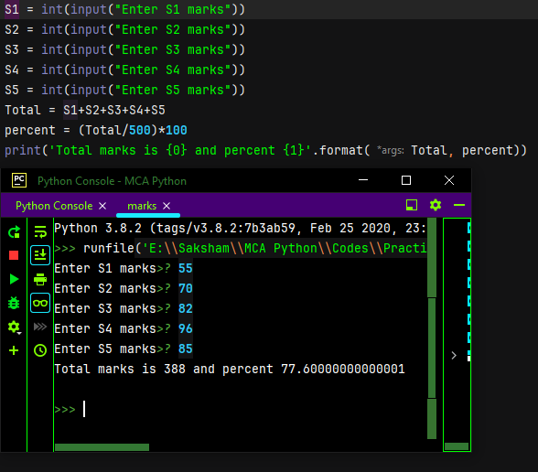

**Ques-5** Write a program to find gross salary.

**Code:**

bs = float(input("Enter the Basic Salary :"))  
if bs < 15000:  
 hra = bs * 0.1  
 da = bs * 0.9  
 print("HRA = ", hra)  
 print("DA = ", da)  
else:  
 hra = 5000  
 da = bs * 0.98  
 print("HRA = ", hra)  
 print("DA = ", da)  
  
gs = bs + hra + da  
print("Gross Salary Rs :", gs)

Output:

Enter the Basic Salary :>? 25000

HRA = 5000

DA = 24500.0

Gross Salary Rs: 54500.0

Snapshot:

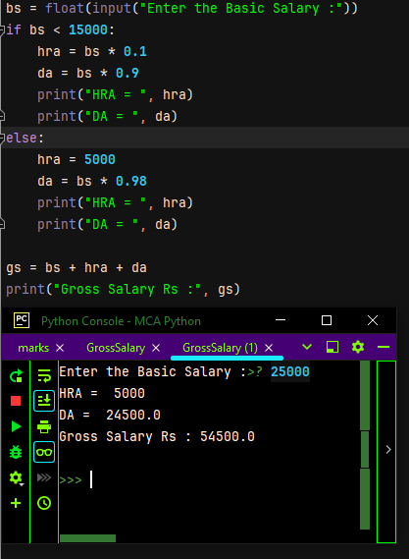

**Ques-6** Write a program to Calculate Area of Circle.

Code:

PI = 3.14  
R = float(input("Enter radius of a circle :"))  
area = PI*R*R  
print("Area of circle = ", area)

Output:

Enter radius of a circle :>? 5

Area of circle = 78.5

Snapshot:

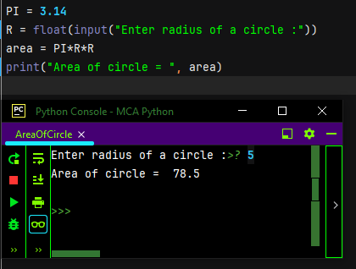

Ques-7 Write a program to Calculate Area of Rectangle.

Code

# Area of rectangle  
  
l = 40  
b = 30  
area = l * b  
print(area)

Output:

area = 1200

Snapshot:

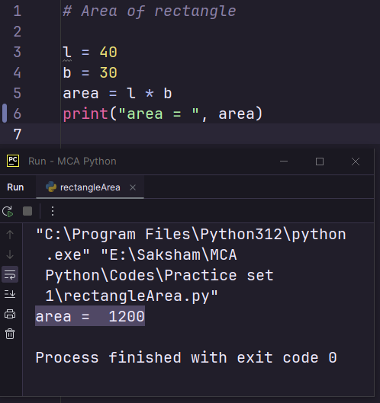

Ques-8 Write a program to Calculate Area of Square

Code:

# Area of square  
  
S = 5  
print("Area Of Square = ", S*S)

Output:

Area Of Square = 25

Snapshot:

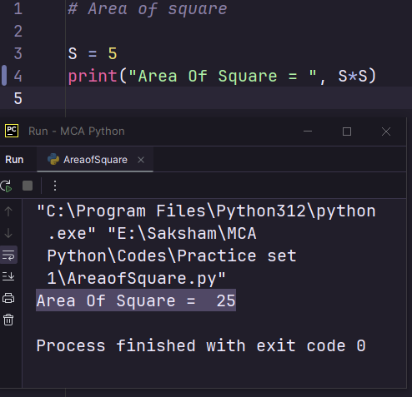

Ques-9 Write a program to swap the values of two variables

Code:

x = int(input("Enter 1st number :"))  
y = int(input("Enter 2nd number :"))  
  
print("Before Swapping :", x, y)  
  
z = x  
x = y  
y = z  
  
print("After Swapping :", x, y)

Output:

Enter 1st number :22

Enter 2nd number :35

Before Swapping : 22 35

After Swapping : 35 22

Snap:

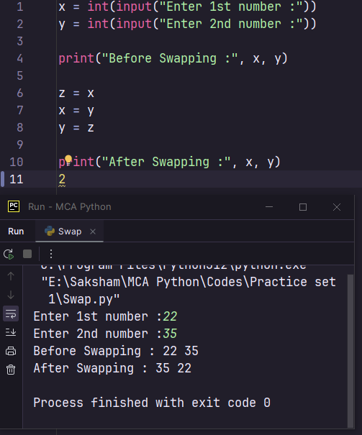

Ques-10 Write a program to swap the values of two variables

without using third variable

Code:

# Swapping two variables without a third variable using arithmetic operations  
# def swap_variables(a, b):  
# a = a + b  
# b = a - b  
# a = a - b  
# return a, b  
  
  
# Example usage  
x = int(input("Enter 1st number :"))  
y = int(input("Enter 2nd number :"))  
  
print("Before Swapping :")  
print("x =", x)  
print("y =", y)  
  
x = x + y  
y = x - y  
x = x - y  
  
# x, y = swap_variables(x, y)  
  
print("After swapping:")  
print("x =", x)  
print("y =", y)

Output:

Enter 1st number :22

Enter 2nd number :36

Before Swapping :

x = 22

y = 36

After swapping:

x = 36

y = 22

Snap:

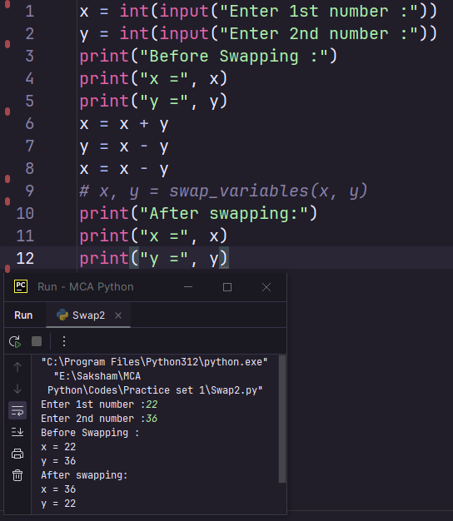

Ques-11 Write a program to Compute Simple Interest

Code:

p = float(input("Enter principal amount :"))  
r = float(input("Enter rate of interest :"))  
t = float(input("Enter time :"))  
  
SI = (p*r*t)/100  
  
print ("Simple Interest = ", SI)

Output:

Enter principal amount :15000

Enter rate of interest :10

Enter time :9

Simple Interest = 13500.0

Snap:

